Computer Network 1
Lab 2
Network tools in Windows and Linux

Student Name: Le Huy Hoang

Student No.: 1652212
I. Objectives
- Know how to configure TCP/IP in Microsoft Windows and Linux operating systems.
- Know common networking tools.
II. Contents
1. Configuration of TCP/IP in Microsoft Windows
1. Configuration parameters of TCP/IP
- Use ipconfig to look for TCP/IP configuration details
- There are commonly two Adapters (Network Interface Card and PPP)
- Note down configuration of Network Interface Card:
IP Address: 192.168.0.163 Subnet Mask: 255.255.255.0
Default Gateway: 192.168.0.1 DNS Server: 192.168.0.1 (tenda access point)
2. Configure TCP/IP: automatic IP or manual
- Start -> Settings -> Control Panel -> Network Connections -> Local Area Connection -> Properties -> Internet Protocol (TCP/IP) -> Properties
2. Configuration of TCP/IP in Linux
- Look into the network configuration file /etc/sysconfig/networking/devices/ifcfg-eth0. Information in file /etc/sysconfig/networking/devices/ifcfg-eth0 is used to configure TCP/IP parameters for the first NIC.
- If there is any change about TCP/IP configuration, change the configuration parameters in /etc/sysconfig/ifcfg-ethx, the, use the following command to restart network service:
# service network restart
3. Learn basic network commands
1. ipconfig (ifconfig in Linux/UNIX)
- System administrator uses this command to examine TCP/IP configuration parameters and also to configure parameters for network interfaces:
- Detail basic syntax of ipconfig/ifconfig:
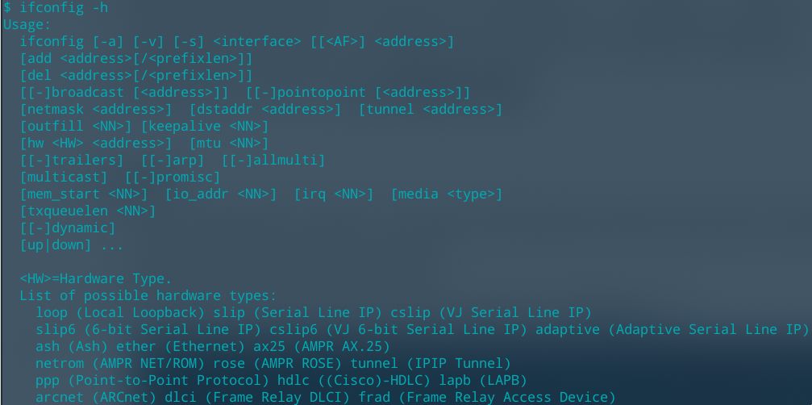
2. netstat
- This command is used to examine information about network connections of the computer and TCP/IP protocols.
- Provide the result when run the command “netstat –a”
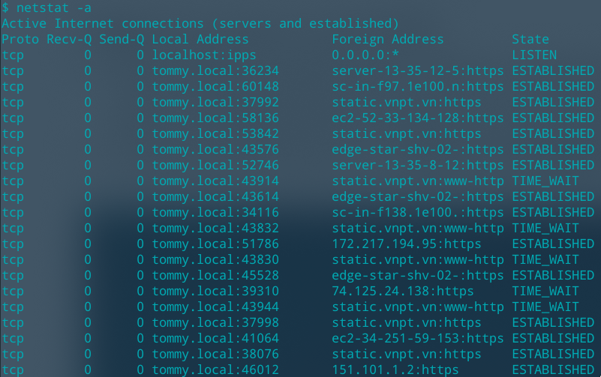
3. tracert (traceroute in Linux/UNIX)
- This command is used to trace a route to a computer in the network. It is usually used to investigate network connections when problems happen.
- Provide the result when run: “tracert www.google.com”
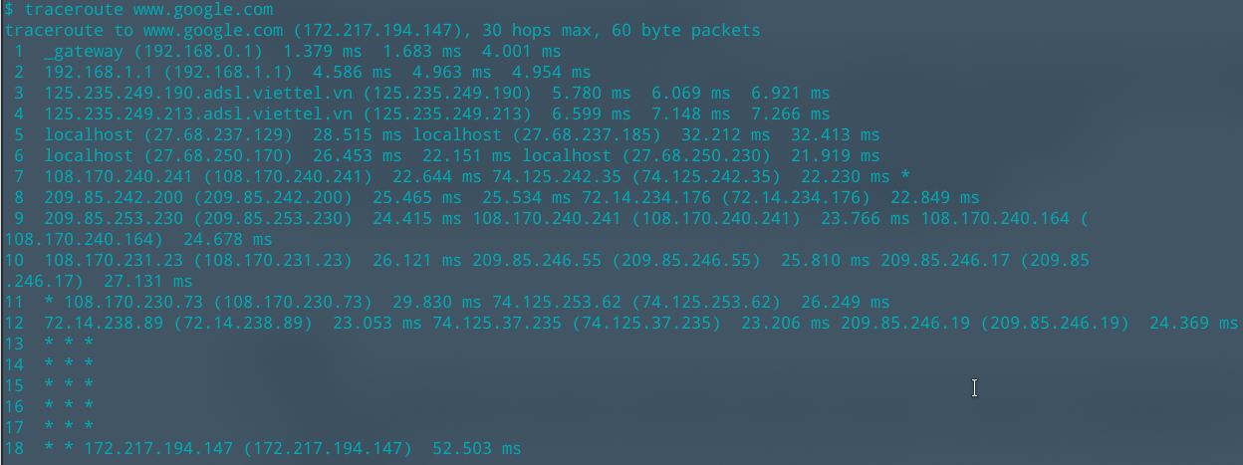

4. route
- Route command is used to examine, add or remove a route in routing table of a computer.
- Provide the result when rung “route PRINT”

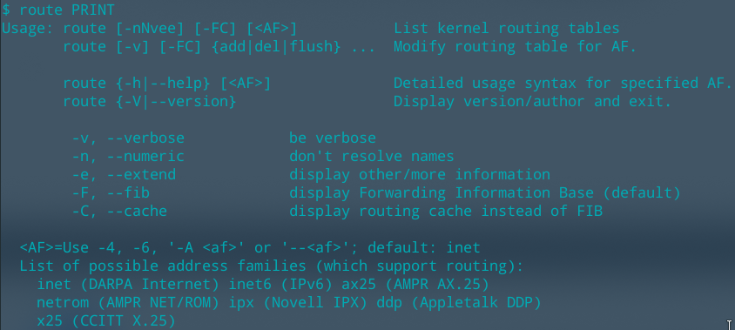
5. ping
- Ping command is used to check if a host in the network is reachable:
- Provide the result when run “ping www.cse.hcmut.edu.vn”

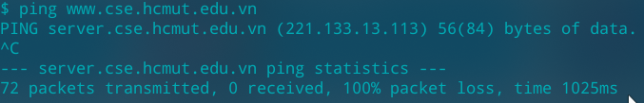
6. nslookup
- nslookup command is used to interact with Domain Name Systems.
- Use nslookup to get IP address of www.vnn.vn (nslookup www.vnn.vn):
- Get IP address of Mail eXchange domain hotmail.com (nslookup -type=MX hotmail.com)
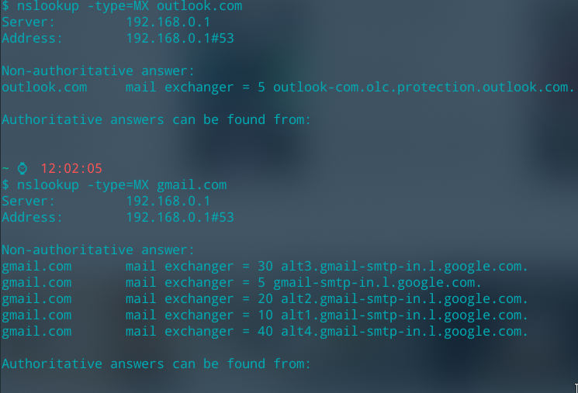
7. SSH (Secure Shell) Client
- SSH client is used for login securely to a remote server.
- Use Google to search for common SSH client on available on the web.



